European bloodlines on your doorstep….
Bay stallion, 169cm, 1999. Registered with Oldenburg and AWHA.
Service fee $1,650 (LFG)
Fresh and chilled semen (shipped Australia-wide).
Renegade Z was a top class showjumper and sire in Europe before coming to Australia, where his progeny are already causing a sensation with their outstanding correctness and athleticism, as well as their super temperaments. In Europe, his older offspring are performing at the highest level (see Ruswil, right, ridden by Carlos Ribas, competing at the Paris Gucci Masters in 2010). Renegade Z boasts an impressive array of European ancestors including Quidam de Revel and Cor de la Bryere, as well as Ramiro Z, sire of legendary jumping mare Ratina Z, and grandsire of Loretta, who produced dressage breeding icons Sandro Hit, Diamond Hit and Royal Hit. | 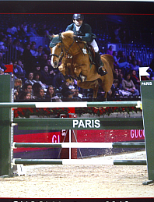
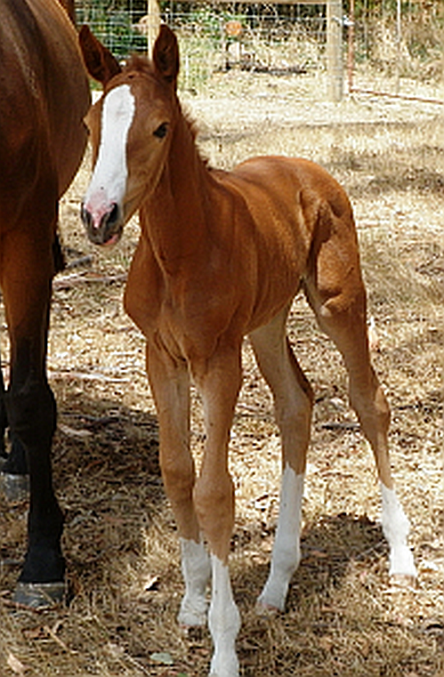 | Gorgeous filly by Renegade Z, born 2011. (Our thanks to Robyn Richards of Kendalee Stables for sharing this photo).  kendaleestables.4upskilling.com.au

Contact us:
Velsha Seaborne 0423 040 540
renegadez.atstud@gmail.com
---------------------------------------------------------------------------------------------------------
Take advantage of this special offer:
20% discount on bookings made and paid for by September 30
--------------------------------------------------------------------
Thanks to The Equine Marketing Group:
www.equinemg.com.au
for our website and logo design

